
THE EMERGENT CHURCH
“Let’s Dialogue”

“In latter times some will depart from the faith, giving heed to deceiving spirits and doctrines of demons…” (1 Tim. 4:1) “…there will be false teachers among you, who will secretly bring in destructive heresies,” (2 Peter 2:1). “For certain men have crept in unnoticed… ungodly men” (Jude 4).

WHAT IS THE EMERGENT CHURCH?

Have you not heard? Have you not read the headline? “The Church is Dead!” The gates of hell have prevailed. But no, the Church is not dead, it is alive! For what is rising is the latest and newest, most up-and-coming world changing movement of the Spirit the church has ever known that will propel it into the next stage of development. The Church is emerging! The time has come, for the Church is evolving, emerging and changing with the times. God is writing His story, and a new chapter is being written. Or is He?

Well, quite frankly many in the Church have not even heard the news of what is emerging and have no idea what the Emergent Church is all about. Some believe that the Emergent Church is a catchall term for people who are disillusioned with the church today and want to do things differently, simply changing the way we “do church.” However, if you think the Emerging Movement is nothing more than a high profile, youth orientated, twenty-something, contemporary worship and music style movement using innovative and unconventional methodologies, then you would be dead wrong! It is all those things, but it is also much more. Emergents seek to fundamentally change Christianity itself. They themselves call for a “New Christianity”. Many call themselves “Progressive Christians” who teach a contemplative method of interpretation of Scripture through dialogue, promote the practice of spiritual disciples (asceticism) and market a new way of “doing church”.

In actuality, there is nothing new about the Emergent Church, but simply a re-emergence of old ideas with up-to-the-minute lingo. They have more in common with 19th century liberalism and medieval Christian mysticism, than with traditional Christianity. They are particularly seductive and dangerous to the members of Christ’s body who have not yet been grounded in sound teaching and can easily be misled. They can even mislead mature minded believers by their stealthy nature. So, it is important for all Christians to understand, at least to some extent, who they are, what they teach and what their agenda is. All seems well and intended, but "Take heed that no one deceives you…” (Matt 24:4). They are leading the flock away from Christ and His Word and unto themselves, to the broad road that leads to destruction.

Paul left the elders at Ephesus his parting words, “take heed to yourselves and to all the flock… For I know this, that after my departure savage wolves will come in among you, not sparing the flock. Also, from among yourselves men will rise up, speaking perverse things, to draw away the disciples after themselves. Therefore, watch and remember…” (Acts 20:29-31).
DEFINING THE EMERGENT CHURCH

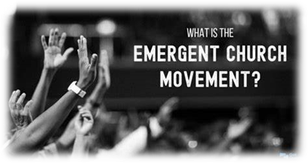
Wikipedia defines the Emergent Church as almost everything under the sun, “The emerging church is a Christian Protestant movement of the late 20th century that crosses a number of theological boundaries… They’re Protestant, evangelical, liberal, progressive, Baptist, reformed, charismatic, and post Protestant, post-evangelical, post liberal, etc.”

“As its name suggests, the emerging church largely consists of Christians involved (or previously involved) in mainstream evangelical churches that have “emerged” from preexisting church structures.”

The Emergent Church takes its name from the idea that the culture today has changed to such an extent that a new church should “emerge” from our post-modern culture. They have embraced the post-modernist worldview as a fact, that nothing is certain, except that that nothing is certain, which itself is self-refuting. If the church is to reach this generation of people, we must “merge” our thinking in the hope that we will “emerge”. What they really hope to do is redefine Christianity as we know it. Create a whole new kind of Christianity.

“The Emerging Church movement is structured on the thought that the gospel needs to be presented in a new and different way and that Christianity should be offered to the world in a new light because we live in a post-modern society, one that cannot easily accept the fundamental biblical teachings of Christianity. And that we kind of evolve as we go along in life, so it is up to us as individuals make up our minds about what is truth as it suits us.”

But let’s not be fooled. Again, there is nothing new, unique, or special about the Emergent Church. It’s the latest liberal version of Christianity, repacked Liberalism, known as “Progressive Christianity”.


Postmodernism is their key component, a counter enlightenment of the modern age. They are all about change, and a call for a “New Reformation” of the church. A call to adapt to a post-modern culture by changing Christianity to make it more relevant and acceptable to post-modernist. It lies with the conviction that changes in the culture signal a new church that is emerging. It has a connection with what preceded it, that is, “Modernism”, yet is fully engaged with the progress of the present, “Postmodernism”. It is mainly focused on deconstruction and the rejection of current forms of church, “Modernism” and believes the church must emerge into a “Postmodern” way of perceiving reality.

They seek to accommodate their version of the gospel to a post-modern culture and strive to be relevant to today’s culture and daily life through alternative worship, called “doing church” and service opportunities. In reality, they end up conforming to the world, rather than transforming it.

If you hear a Relevant say, “We only want to change the methodology and not the message.” Don’t believe it. It’s a big lie! Their goal is to move from a traditional understanding of mostly protestant Evangelicalism into postmodern expressions of thought. What really emerges at the end of the road is Pantheism (All is God and God is all) or Panentheistic (God is in all).

According to Bob Dewaay in his well-researched book “The Emergent Church, Undefining Christianity,” found that Emergent theology is very difficult to categorize and understand precisely. Many find their positions impossible to understand, irrational, and even silly. It is difficult to pin down, because their theology is in flux, it is still emerging and will emerge in the process.

They are a mystery to many. Defining Emergent is like attempting to pin Jello to a wall. They like to use the hidden ball trick with their words. The difficulty lies in their “epistemology”, which is, how we know what we know. In Emergent thinking, knowledge and truth are not something one can know in the present with any certainty, but certain knowledge lies in the future, it becomes known. As a result, they destroy the foundations that undergird human reason and communication.


Emergents are deliberately obscure. They view obscurity as useful. They practice “semantic mysticism, a means of using words for the value in creating communication while disconnecting them from rational meaning.” Emergents work very hard to obscure their foundational beliefs. Vagaries are the nuts and bolts of Emergent “conversation.” They do their best not to be understood, deliberately using misdirection, by doing so, they think they are being clever, and coy. Using contradicting or even being provocative is a better way of helping people emerge from what they call old categories of thought (traditional Christian teaching) into a new synthesis (a new combination of truths yet to be discovered through group conversation, mystical experiences, or contemplative Bible reading and prayer). “Emergent theologians write in a cryptic, difficult manner, taking pains to be ambiguous, paradoxical and vague” – just as they see the Scriptures.


The problem is they have no formal statement of beliefs because they deny propositional truth, making “truth claims”. Why? All truth is relative and subjective. As a result, they are “carried about with various and strange doctrines” (Heb. 13:9). They make distinctive beliefs and practices unnecessary. They say, “Dogmatism is dangerous, microscopic that is, closed minded, divisive and unloving.” They feel free to believe whatever they want and practice their religion as they see fit. Religion with no boundaries or limits, “free style spirituality.” The “Outback” of Christianity, “No rules, just right”, somehow, so they think.
John Taylor says, “It’s not easy to clearly define the emerging movement, because the movement away from traditional fundamental Christian teachings has a huge number of facets and variant of beliefs, though there are churches, pastors, and organizations, like the Emergent Village that maintain their own beliefs. The Emergent Village describe themselves as the official network of like-minded leaders and churches involved in one particular stream of emerging conversation.”

Emergents have no organizational structure and are a loose connection of so-called Christians having “group conversations” searching for the truth. They are trans-religious, Trans-Christian, inter-spiritual, something like a crossover religion.

THE EMERGENCE OF THE EMERGENT CHURCH – A LITTLE HISTORY

The genesis of the Emergent Church is traced back to the mid 1990’s to the Leadership Network -- Chris Seay, Tony Jones, Dan Kimball, and Andrew Jones. They created a resource to help leaders of innovative postmodern churches to connect. The Leadership Network hired Doug Pagitt to lead and organize events. It soon included Brian McLaren and others. It brought together leaders of megachurches and was funded by Bob Buford, closely connected to two megachurch leaders Rick Warren (The Purpose Driven Network) and Bill Hybels (Willow Creek Association). The three formed, banked, and promoted the Emergent Church. They also consulted with and began to follow the business management practices of Peter Drucker who had a worldwide reputation as “the father of modern marketing.” Time Magazine named Brian McLaren the “Elder Statesmen” of the Emergent Church. The three organizations began targeting their Emergent products to church leaders and pastors, based on Drucker’s business and marketing management ideas. They borrowed the best business practices of Drucker and incorporated them into their mega-ministries. The original team “emerged” into what is known today as the “Emergent”, a broad category that encompasses a wide variety of Churches who are having the same group conversation or “deep dialogue.”

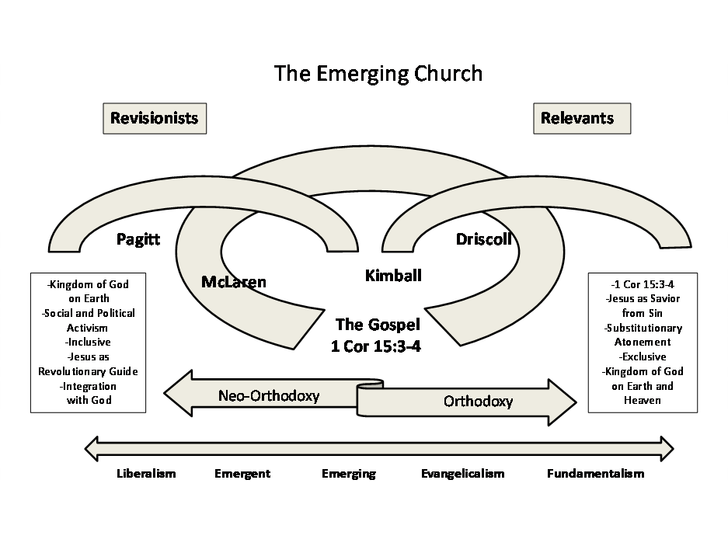
Brian Driscoll classifies the Emergent Church into three categories or streams:

- Relevants – are churches or pastors who are at least privately theologically conservative evangelical, but are also interested in updating and changing worship, preaching styles, and church leadership structures. Their goal is to be more relevant and appealing to postmodern minded people, the so called “unchurched”, a polite way of saying “pagans.” They want to change the way of “doing church” and “Make Church Fun Again” in order to reach the unreached. In order to do so they watered down or eliminated at least in public outreaches the more offensive elements of the gospel message, such as sin, the cross and resurrection, miracles, eternal and temporal judgment of the wicked. They claim to be Orthodoxy and appear to uphold traditional Christian teaching, even conservative Christian doctrine in their statements of faith. Relevants would include Rick Warren and Bill Hybels and other franchised churches.
- Reconstructionists – are generally privately theologically evangelical but are totally dissatisfied with the current or above form of “doing church”, and seek to move to informal church forms, such as house churches. Church leaders Neil Cole, Michael Frost, and Alan Hirsh are considered Reconstructionist.
- Revisionists – are the theological liberals, also known today as “Progressives”, who not only want to make outward changes of “doing church”, but also questioning fundamental and traditional doctrines of the Christian faith, which they call “dead orthodoxy”. They prefer a more “Generous Orthodoxy”. They want to appear to be more inclusive and tolerant, instead of exclusive and narrow-minded. The most well know Revisionists are Brian McLaren, Doug Pagitt, and Rob Bell.


More recently Emergent leaders have reorganized as the “CANA Initiative”. CANA (Connect, Advocate, Nourish, and Act) is a collection of church leaders, organizations and networks across the US who collaborate to embody and act on courageous, liberating and compassion faith.” “This million-dollar initiative’s goal is to bring together a global third-party network of Emergent Christianity for the development and maturity of a new generation of Emergent leaders…”

Some prominent Evangelical leaders have dismissed the Emergent Church as being dead. However, others say that it has spread so far that it has been absorbed into the fabric of the American Church. Many churches have adopted Emergent ideas, though they would not call themselves Emergent. Even hard core Emergents may not use the term openly. They like being stealthy. They have simply reemerged once again as the CANA Initiative, a network of networks made up of the same Emergent cast of characters, who are not even sure what they want to call themselves: “Emergent”, “Convergent”, “A New Kind of Christianity”, “Progressive or Generous Christianity”—movement in constant change or reimaging themselves. “The end result is a global religion rallying around a powerless social gospel.”

IDENTIIFYING THE EMERGENT CHURCH

The first thing you need to know about Emergents is that they are insidious, deceptive, sneaky, and dangerous to the health of the true Church. For those on the alert these wolves in sheep’s clothing can be identified by their “conversation”. False teachers are always known by the words they speak (Mt. 12:33-37). Here are some “catchwords” in order to identify an Emergent so that they will not creep in unnoticed to your church.

Key Buzzwords:

- “Let’s dialogue” or their favorite “Join the Conversation”, the means or process of discovering truth; It’s their approach to theology – the “knowledge of God” will be made known by the process of “conversation”; “the interpretive group in dialogue.”
- “Spiritual Formation” – Christian Mysticism (asceticism) disguised as leadership training for your spiritual development.

- Contemplative Prayer or Spirituality; Centering Prayer, Quieting, Listening, or Silent Reading – Emergent ways of listening to God. Silence is the space between your thoughts where God consciousness is experienced.
- “Missional” – the importance of community; using people’s cultural understanding to reach them with the social gospel and help solve social ills. Their “Great Commission” is making world peace and working together with other religions to help the poor and oppressed.
- “Social Justice” – Taking up various progressive causes in order to help God create a better world for all.
- “Unity” or “Co-existence” – Emergents believe everyone ought to unite around their beliefs and causes. Despite their rhetoric, the last twenty years have shown that what has emerged is a movement that divided traditional conservative churches. The Emergent Church itself has become divided with radical ideas and various definitions of faith. “In the last times there will be those who are the ones who cause divisions” (Jude 18-19) [NASU].
- Finding your “Identity” – The modern church has an identity crisis, and the Emergent Church is here to help people find their identity by looking deep within oneself.
- “God’s Story”, the “Narrative”, “Narrative Theology” -– “The theological idea that encourages believers to look at the story that God has told through the Word and examine how God is using their personal life to construct a new story that will further His kingdom.”
- “Transition” from the tangible to the intangible; from the Objective to the Subjective.
- “Participation” – a movement away from expository bible preaching by an authoritative pastor, to a facilitator who leads all to participate in conversation in the search for meaning and truth. They encourage dialogue or conversation about faith within the church and to re-think the role of the pastor, to devalue the influential pastor’s dominance in the church through the preaching of the Word.

FURTHER IDENTIFICAITON

- Also known as: Conversational Christianity; Incarnational and Relational Christianity; “Progressive Christianity” as opposed to “Inherited or Traditional Christianity”, which they consider to be too rigid.
- It embraces “post-Modernism”, which is characterized by broad skepticism, subjectivism, and relativism. It denies that truth, especially religious truth can be known with any certainty.
- Embraces Open Source, Open Theism, or Process Theology – God knows the past, but does not know what the future holds, therefore He cannot predict the future. God Himself is in the process of evolving, changing.
- Pastor John MacArthur calls the Emergent Church the “New Liberalism.”
- Panentheistic, meaning God’s spirit is in everything. In Miami, Florida there is a community known as “Wynwood” where modern art and graffiti come together—my own invention. The Emergent church is in a way where liberalism and new age philosophies have come together. As C.S. Lewis said similarly that “All false religions end up on the broad road to pantheism.”

To Emergents, Christianity should be:

- Personal Experience over Logical Reasoning
- Subjectivity over Objectivity
- Spirituality/Mysticism over Doctrine and Absolutes
- Images over Words
- Feelings over Truth
- Earthy Justice over Eternal Salvation
- Social Action over Internal Transformation
- Environmentalism over Cataclysmic Destruction (leading to a new heaven and earth)
- Gradual Change over Sudden Change
- Inclusive over Exclusive
- Nonjudgmental over Judgmentalism/Fundamentalism
- Progressive over Inherited

THE EMERGENT HOPE – A DREAM WORLD

The best way to understand Emergent Theology is by examining their eschatology, “future things.” It explains the rest of their beliefs and practices. You begin at the end, and their “Theology of Hope.” Their hope is to create a better world without the prospect of future judgement from God. They have a recurring mantra, “everything is evolving to a better future which will be the Kingdom of God.” This Kingdom emerges through the process of history, because God is the future drawing everything to Himself… God is still creating, and we can be co-(re)creators of the world with God. So, the key idea is God bringing history toward a glorious kingdom of God on earth without future judgement.

This “Theology of Hope” is one they like best, because it is one that creates a world that has a universally bright future, with no pending doom of judgement. “They loathe dispensationalism more than all others because their claims are just the opposite: that the world is getting ever more sinful and is sliding toward a cataclysmic judgement.” They think and hope we can go to work to actually help God fulfill His dream of a better world. God imagines an ideal future for the world that we can join and help actualize.


“Theirs is an eschatology of wishful thinking… a dream world where history is a process of unfolding, a becoming… It is romanticism returned that thrives on the mysterious and the unknown, imaging that something wonderful and ideal is unfolding and becoming like the Romantics of old.”

How is this possible with so much division in the world? Well, this is where it begins to get complicated and really weird. Their dream world comes about through a process of emerging contradictions (see Hegel) as leading to the Kingdom of God, a better world. Differences, tensions, paradoxes, are a reconciling movement toward oneness with the other. “The more irreconcilable various theological positions appear to be, the closer we are to experiencing truth.

So, God is doing something in creation that will cause paradise to emerge within time without judgement. God needs our help! Helping God solve world problems is promoted by various streams of liberalism, similar to “Liberation Theology”. However, nothing is certain or knowable, except that we will somehow succeed in making a better world, that is “The Hope”, God’s dream. Changing society is essential to their dream. So, “join the revolutionary movement of change.”

First of all, Emergents pervert the Scripture concerning the Kingdom of God to fit their eschatological dream world. Then, they create a theology out of their own mind where everything in the world is getting better and God is drawing all things toward the future that will be good for all and devoid of cataclysmic judgement.

Emergents appear to be more optimistic and hopeful. A good time feel good religion. Emergent romanticists are “dreamers” (Jude 8) who desire a wonderful positive experience that makes them feel closer to God. They predict an optimistic future for all. But their “dream world”, which they have made up in their own mind, is out of touch with reality. This is what the Lord Almighty says about dreamers:
“Do not listen to what the prophets are prophesying to you; they fill you with false hopes. They speak visions from their own minds, not from the mouth of the Lord. They keep saying to those who despise me, 'The Lord says: You will have peace.' And to all who follow the stubbornness of their hearts they say, 'No harm will come to you” (Jer. 23:16-17) [NIV].

Jude calls them in verse 12, “clouds without water”, who promise great things, but are empty of substance. They are “grumblers and complainers” (16) habitually dissatisfied with fundamental Christian doctrine, especially the doctrine of coming judgement. Why? They simply don’t like it. For one, so that they may pursue their own lusts. They are undeterred by past solemn examples of judgement upon mankind and the spirit world (5-15). They blaspheme “speak evil against” and are ignorant of God’s plan. Instead, they accuse the God who is “full of compassion” (Ps. 86:15) of being a blunderer and cruel.

Though they claim to be truly spiritual, they are not, because they are void of the Spirit of God in them. They are utterly unspiritual, virtually void of the spiritual faculty. “These are sensual persons, who cause divisions, not having the Spirit.” (Jude 19) “But you, beloved, who have the Spirit, remember the words which were spoken before by the apostles of our Lord Jesus Christ: how they told you that there would be mockers in the last time who would walk according to their own ungodly lusts.” (Jude 17-18) However, for them their dream will turn into a nightmare when the Lord comes to execute judgement on all (Jude15).

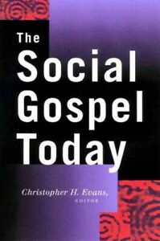
THE SOCIAL GOSPEL – CREATING A BETTER WORLD

Helping God find Himself and achieving the dream of creating a better world is accomplished together through social action. And somehow, we can help God make His dream a reality through the process. This is based on their vague idea of how to make the world a better place. “Helping people solve world problems”, they think they know and will be successful in making it happen. You know, “Build Back Better.”

The Emergent Church is an “interpretative community in dialogue” working toward a utopian outcome through cooperation in order to create their own social paradise. What really matters to the Emergent, is that we discover a problem to care about and do your best to correct it. It’s the “Social Gospel” repacked -- fixing social problems. And fixing the world is our salvation by essentially doing good deeds and bringing social change. An Emergent pastor Rev. Steven Lewis calls the Emergent Church “humanitarian spirituality” and said, “Salvation in the 21st century is being a good human being”.

Their mission, which they call “Missional” is tends to embrace improving society now, correcting society’s ills, and righting the wrongs of society. Missional is the idea that any work that makes a better place brings us toward the ideal future. What matters most to them is being Missional together. “God imagines an ideal future for the world that we can join and help actualize.” It’s what some call, “God’s Story”. Come join or be part of “God’s Story.”

The huge flaw: “If we cannot know the truth about anything with certainty until the future, then we really cannot know what our future mission is either.” It’s a mission without a goal!

The real problem is there is no objective evidence that the world is turning into a better place, nor ever will through social activism. To begin with, the Bible teaches that outward social change begins internally with a renewed mind shaped by an objective understanding of the written Word.


All who have sought to socially reconstruct reality has failed, because sin is entrenched so deeply in the human heart and mind that this world will not become a better place until Christ, the King returns in judgement, dissolving this present world, and creating a new heaven and earth in which only righteousness will dwell. This coming reality in our minds motivates us to live in holy conduct and godliness (2 Pt. 3:11-13).

By the way, the only access we have to the future is the promises of God objectively understood by Scripture whose meaning can be known. Prophecy is God’s unveiling of the future, the provided evidence of future events and the only reliable source. What will emerge is no dream! Future judgement is a reality that everyone must accept. So, deal with it! Or better, “Repent!”

In the end the Emergent Church produces doubt and despair, not hope. They create the ‘ultimate hopelessness’ with respect to knowing truth. It is a false belief that gives the illusion of hope as a hopeless way of thinking, as they fall into the quagmire of unknowing.

PROCESS THEOLOGY – AN EVOLVING GOD

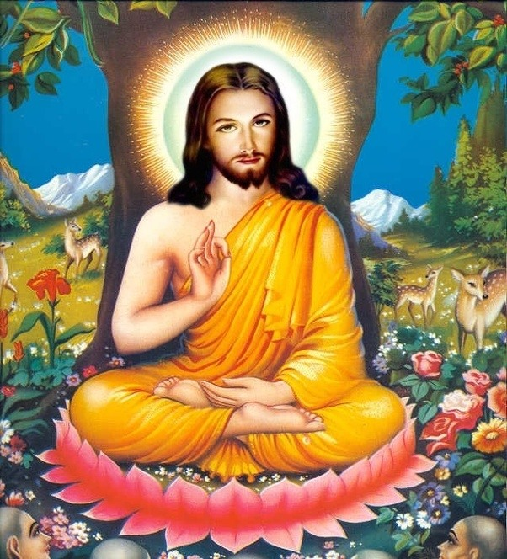
Their “Theology of Hope” is derived from their view of God Himself. God is viewed more as an impersonal consciousness. God changes and evolves. Instead of being the Creator He is the “Evolver.” Emergent says, “God has not arrived yet, but “is becoming”. He is not immutable, that is, never changing, eternally sufficient in His person. God is in the process of becoming more divine. And God needs our help. We can help in the emergence of the cosmic consciousness through meditation and help God find Himself.

Jesus Himself was a Buddha-type, who realized more than most of the divine from within. Jesus was the first Christian who simply gained the greatest potency of God consciousness. “He was not God become man, but man become godly.”
We ourselves can be more like Jesus when we also realize the divine within us, described as “the kingdom of God.” Your divine consciousness, knowledge of God, is accessed through communal conversation, spiritual meditation, and mystical experiences. Divine consciousness emerges more and more in the process. This is the miracle of emergence—"A mystical theology where all humans can find God by discovering the undefined rhythm within.”

In 1999, Zane Hodges spoke of a present movement gathering momentum, one related to so-called “contemplative spirituality”, in which Roman Catholic and Buddhist mysticism are merged.

“Within this system of thought Jesus is stripped of His uniqueness as ‘the only begotten’ Son of God and is ascribed a divinity which in character is no different than the divinity belonging to all men. According to this perspective, each and every individual is ‘one’ with God and Jesus simply realized this oneness to a greater degree than others. He is not the Christ in the Johannine sense of mankind’s one and only Savior (John 1:29-4:42).”

In this way, Emergents “deny that Jesus is the Christ” (2:22) and are teaching the lie of the many antichrists that Apostle John says have already come and precede the lie of the Antichrist who is coming (2:18). Hodges suggest that this new wave of ideas, could easily form the basis of a universal synthesis of mankind’s religion and could also become the basis of the new world religion sponsored by the Man of Sin (I Thess. 2:3-12), also called the Beast (Rev. 13:1-10), and the False Prophet (13:11-17). “It would be ironic if the contemporary system closest to the false doctrine of the “many antichrists” should turn out to be the final form of religious deception.”

DECONSTRUCTION AND RECONSTRUCTION – OUT WITH THE OLD AND IN WITH THE NEW

Emergents attempt to promote their ideas as new, unique, and innovative. However, they oppose nearly every major Christian doctrine. They oppose truth claims, i.e., doctrinal statements, claiming that truth claims, doctrine, that is, creates boundaries and supposedly they keep people out of the church. Statements of faith, and propositional truth claims, they assert are “conversation stoppers.”

The process “of becoming” begins with social and theological deconstruction. The demolition of the old structures, that is, fundamental Christianity, especially dispensationalism. Only then can social and theological reconstruction begin to build a better ideal future reality. This is the emergent version of the “cancel culture.” They’re not singing that old-time religion. In fact, they are not singing much at all. Congregational singing is out, and the praise band performances are in. Traditional hymns are out and chanting and mantra style ditties are in. Dead letter doctrine is out, and new age imagination is the rave.

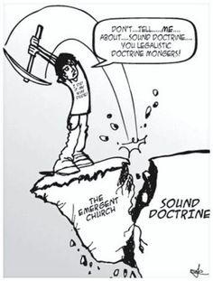
Emergence must defeat traditional Christian doctrine by a process of “undefining or reconstructing Christianity.” Some believe “that it is necessary to deconstruct modern Christian dogma, by engaging dialogue, rather than proclaiming a predigested message…” As they see it, old things must pass away, and new things must come. A new emerging church is in the process of evolving past earlier forms of God consciences, toward a higher form. Those who cling onto old truth claims are immature, “theological babies”, who need to grow up to what is emerging and catch the wave.

The first deconstruction accorded in the Garden when the Deceiver questioned the one and only interpretation God had given. Satan attacked God’s language. Emergents attack the use of language of the Bible, the very words. They ridicule and mock the idea that God communicated to mankind through simple human language. The deconstruction begins with deconstructing language itself,

“Once language is deconstructed of its clear meaning ‘truth’ becomes experiential and subjective so the mystical practices are taught in the place of sound biblical doctrine. Since Emergents consider words to be inadequate to convey truth and meaning, mysticism provides for them an experienced truth rather than understood truth.”

“Emergents assault the Bible’s meaning and clarity, de-prioritized the place of Scripture and emphasize intuition and experiential understanding.” They have a zeal for God apart from knowledge. They are Gnostic like with their on going and never-ending search for hidden mysteries and secret messages. Once students of the Bible embrace Emergent Theology, they readily admit that they have no idea what most of the Bible means, and one wonders whether they even care.

They intentionally promote obscurity and go out of their way to be provocative, mischievous, and unclear. “They replace established certainty with conversation of obscurity and make the Bible a book of confusion rather than illuminating its simplicity… and seek to draw Christian away from the simplicity of Christ and the Gospel with a conversation of obscurity, doubt and confusion.”

“…they perceive to be intellectual and emotional human superiority, although they may not realize it or see themselves that way. After all, if you want to modify God’s inherent Word and create new ways to define the gospel and Christianity in general, surely you must be more capable than God and know something He doesn’t.”

“IT IS FINISHED” – THE WORD DEVELOPED AND ESTABLISHED

The answer to reviving the church today is not some new innovative Christianity, but the old Christianity already revealed in the Scriptures. We do not need a new and redefined Christianity, but a revived Christianity—"Revive us again; Fill each heart with Thy love; May each soul be rekindled with fire from above.”

Today’s saints—those who have been made right before God by faith alone in Christ alone—need to be exhorted “to contend earnestly for the faith which was once for all delivered to the saints” (Jude 3) “The faith”, the body of foundational doctrine, does not need improvement or made better. There is no new way of doing theology. “The faith is not an emerging, converging, progressive thing. It is not an unfinished faith to be molded and completed by successive generations. We do not need to reinvent Christianity.” There is no need to relay the foundation that Christ and the Apostles already laid down. We simply build on top of “the faith” foundation.

Emergents are bad ministers whom “the Spirit says in latter times some will ‘depart from the faith’ (apostates), giving heed to deceiving spirits and doctrines of demons, speaking lies in hypocrisy…” (1 Tim 4:1-2a). A good minister is nourished in the word of faith and good doctrine which he carefully follows, who then takes those things and commands and teaches others likewise (4:6,11).

Paul instructs Timothy “to be strong in the grace that is in Christ Jesus and the things that you have heard from me… count these to faithful men who will be able to teach others also” (2 Tim. 2:1-2). The younger Timothy was to pass Paul’s faith which he received from Christ to others who in turn will pass it on to more brothers and sisters in Christ who will then do likewise, generation after generation. No one adds anything new, just passes it on. In fact, God promises to send a plague upon those who add to His Word (Rev. 22:18).

“All Scripture is given by inspiration of God—God’s gift to man—and is profitable for doctrine, for reproof, for correction, for instruction in righteousness, that the man of God may be complete, thoroughly equipped for every good work” (2 Tim. 3:16-17).

The writings that were given by God are His Words that proceed from His very mouth and mind. And these Words were revealed to us through His Spirit, “…yes, the deep things of God” (I Cor. 1:10). They are fully sufficient to bring the man of God to maturity and completeness. No additional God-breathed Word is necessary. For Peter says, “…His divine power has given to us all things that pertain to life and godliness, through the knowledge of Him…” (2 Peter 1:3).


Paul instructed Timothy to “Preach the Word”, just as Jesus instructed Peter to, “Feed My sheep”. And Paul instructs Titus, “to speak things which are proper for sound doctrine” (Titus 2:1). “Therefore, brethren, stand fast and hold the traditions which you were taught, whether by word or our epistle” (2 Thess. 2:15). The traditions which the Thessalonians received was, “the word of God which you heard from us, you welcomed it not as the word of men, but as it is in truth, the word of God” (1 Thess. 2:13).

Paul tells Timothy to guard the body of truth that was given to him, and not to follow those who had already strayed from “the faith” (1 Tim. 6:20-21). Paul would later tell him that even more perilous times will come in the last days…” (2 Tim 3:1), when ungodly persons will creep or sneak into the church (3:6), they will be evil men and impostors who will grow worse and worse, deceiving and being deceived” (3:13). “For the time will come when men will not endure sound doctrine, but according to their own desires, because they have itching ears, they will heap up for themselves teachers; and they will turn their ears away from the truth, and be turned aside to fables” (4:3-4).


Paul warned the Ephesian elders to, “take heed to yourselves and to all the flock… For I know this, that after my departure savage wolves will come in among you, not sparing the flock. Also, from among yourselves men will rise up, speaking perverse things, to draw away the disciples after themselves” (Acts 20:28-30).

Peter warned that even as there were false prophets among the Jewish people, there will be false teachers among you, who will secretly bring in destructive heresies, even denying the Lord who bought them, and bring on themselves swift destruction” (2 Peter 2:1). By the time Jude writes his short letter several years later certain men had already crept in unnoticed… ungodly men, who turn the grace of our God into lewdness and deny the only Lord God and our Lord Jesus Christ” (Jude 4).

NOTHING NEW HERE – BUILT ON THE FOUNDATION OF THE APOSTLES

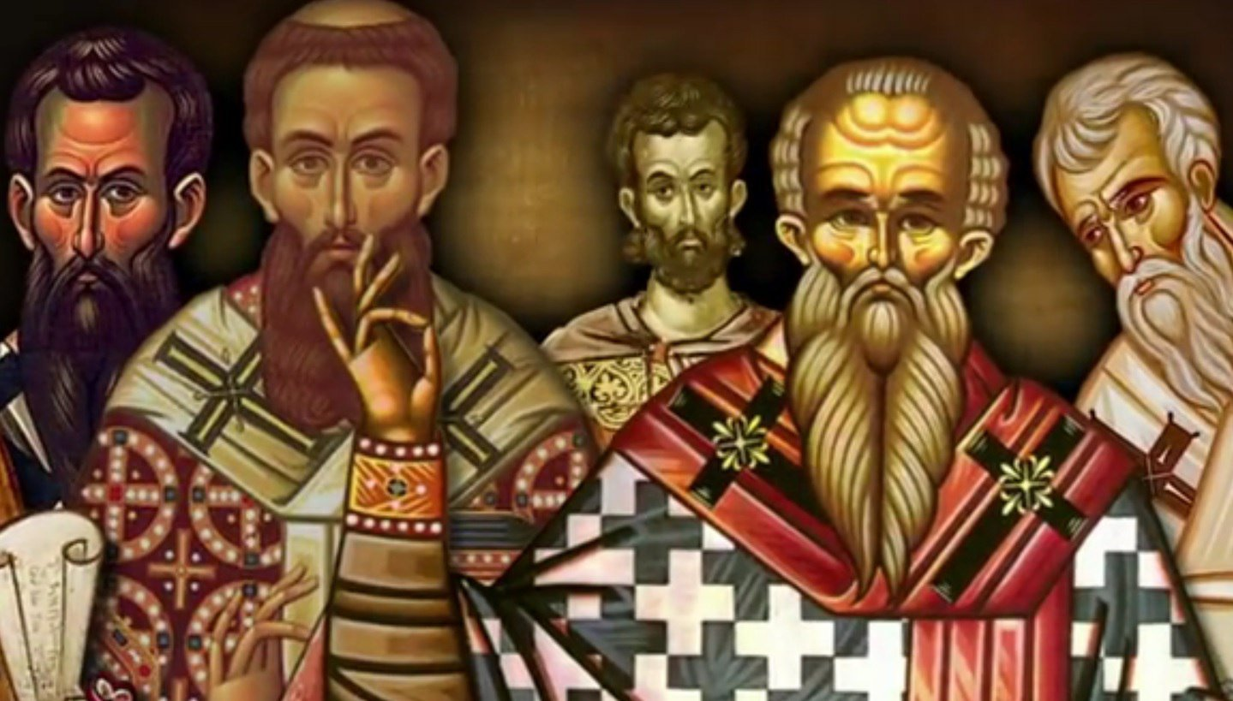
A generation or so later the church fathers knew nothing of a progressive Christianity, some theological truth yet to be revealed. They taught nothing new or innovative. The only ones who did were the Gnostics, who accepted spiritual knowledge apart from the Word.

Irenaeus (130-202) had received “the faith”, the apostles teaching, and thought no one could make any new additions to the faith because he considered it to be complete. He believed, he and the other believers “possessed perfect knowledge” from the apostles and mentioned there were some who unlawfully boastfully asserted themselves as “improvers of the apostles.”

Like the Gnostics of old, Emergents pride themselves of introducing new and innovative ways of “doing church or theology”, but in fact are simply adopting or reintroducing many ancient practices of the medieval church of the west (Roman Catholic) and of the east (Orthodox) to a new generation of naive Christians who are not grounded in “the faith”. They merge many of their ideas with ancient philosophies, such as Plato, creating a mix called, “Christoplatonism”.

Jesus and the apostles laid the foundation and Emergents lay the foundation aside. They are not seekers of truth who have found it, but are seekers who question the truth and deny anyone can find it logically or rationally. They have rejected the rational objective truth and abandoned themselves to the subjective.

Jesus said to those who believed in Him, “abide in His Word”. Only those believers who abide, remain or continue in His word would be called His disciples, and only then would they know the truth, truth that would make them free (Jn. 8:31-32). Because Emergents have rejected the truth once delivered and established by God, they are like those who are always learning and never able to come to the knowledge of the truth.” (2 Tim. 3:7), wandering in the wilderness of subjectivism. They keep searching everywhere except the one place where the truth can be found, “the body of objective truth called ‘the faith’ once delivered to the saints.”

CONVERSATION – BECOMING PART OF GOD’S STORY

Emergents call their endeavor for the truth a “conversation” or “dialogue” where all opinions are valid. The conversation begins with questioning and altering God’s clear and objective statements in Scripture. “Did God really say...?” Satan had the first “conversation” with Eve in order to deconstruct what God meant by what He said. Emergent Postmodernism has taken on the Deceivers’ role of questioning God’s objectively plain and simple Word.

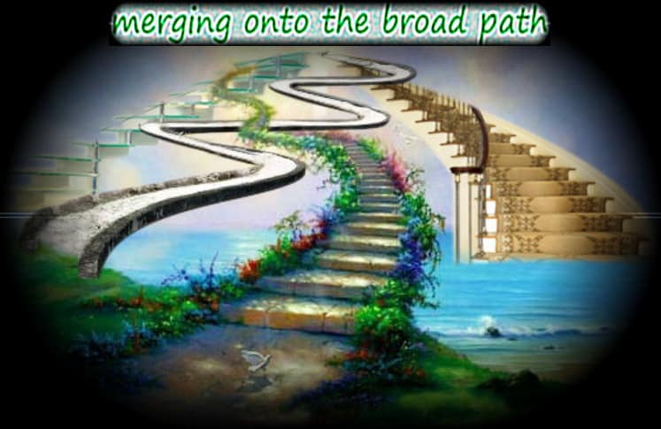
The “dialogue approach” is necessitated by the rejection of objectivity in Biblical exegesis. They have determined that humanity cannot know objectively the Spirit inspired author’s intent or meaning. The original author’s intended meaning can be ignored. Therefore, they replace an objective interpretation of the author’s intent for the Holy Spirit inspired community, of readers who then find their own unique meaning – “an interpretive community in dialogue.”

Why have they adapted the subjective over the objective method of interpretation? The answer is simple: They do not like what the Bible says when it is interpreted in an objective manner—using the historical/grammatical method of interpretation. Even though the objective or literal method of interpretation is completely valid, they do not like what he leads too—man being held accountable for his actions/sins and the racial steps (Cross) that God took to remedy the problem. “You will not surely die…”—a denial of the plain and simple objective interpretation of God’s words: “the day you eat of this tree you will surely die.”
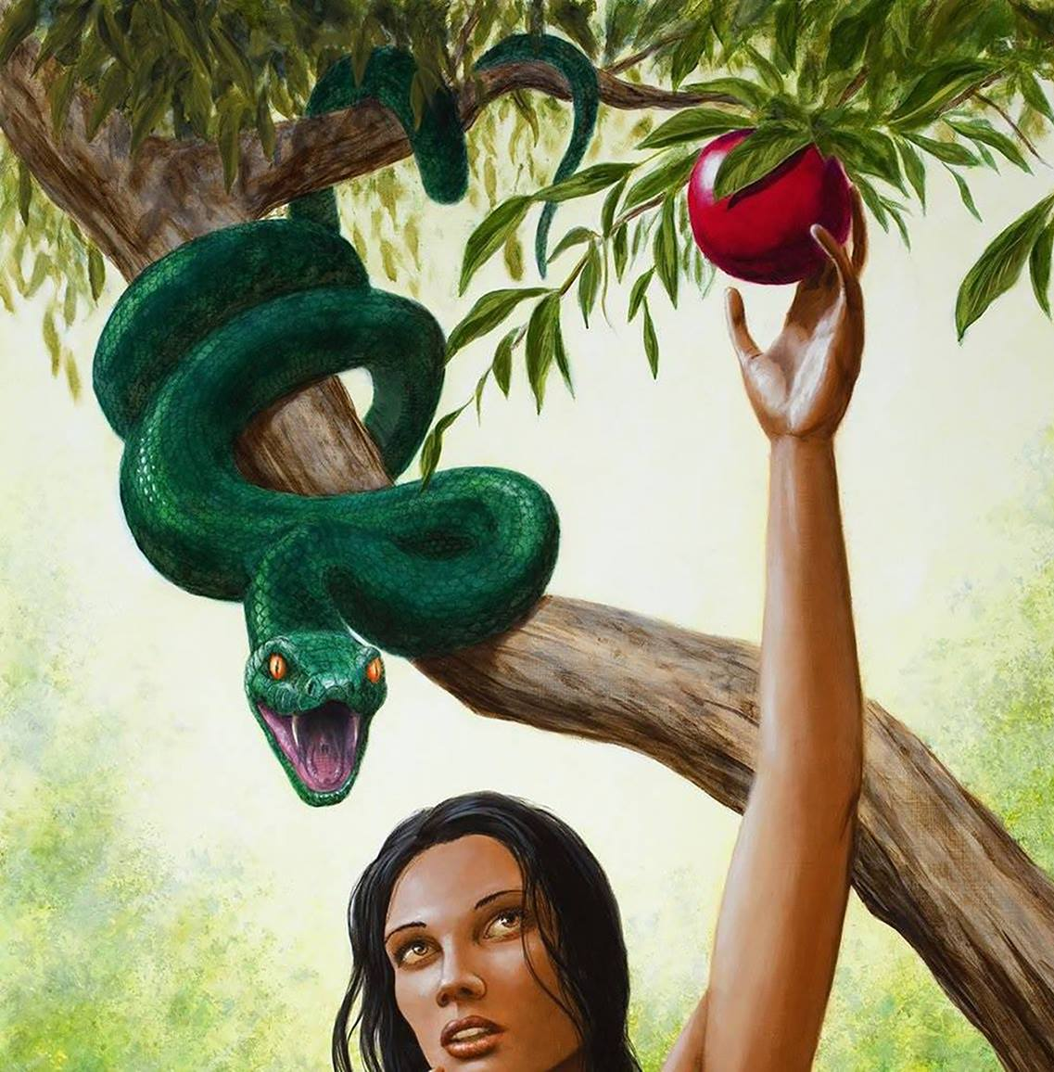
Satan and Eve became the first interpretative community. Satan: “I’ll promise you a better world without judgement, enlarge your knowledge and you can dream up of any world you desire. Be your own creator god.” What does Satan and the Emergent Church promise? Something more—knowledge and power. The power to interpret the Bible as one pleases. The Emergent Church is a community of readers free to determine whatever meaning they desire—a theological free-for-all—but, more like the blind leading the blind.

They falsely think that they are free to invent an approach to God according to their own determination. Where do they think they have the right to ignore what God has objectively spoken in His Word and utilizes spiritual practices (meditations, trances, chants, and mantras, etc.) that were forbidden in the Law?

TO TELL THE TRUTH – BY CONSENSUS OR COMMUNITY


Having embraced subjectivity, uncertainty, and doubt Emergents abandoned Biblical exegesis completely. Instead of searching for a single meaning the Bible student is to consider various meanings of Scriptures yet to be determined by him subjectively or by a group process determining the meaning by consensus. All various meanings are valid, to be determined by the reader, not the author. Whatever makes the reader feel closer to God is preferable. “Instead of searching the Scriptures by ordinary means of interpretation to understand meaning and truth, the Emergent Church substitutes multiple complex sources incomprehensible to most… General revelation, linguistics, church tradition, human culture, philosophical speculations and constructs are their theology—ideas of God.”

The traditional modern method of interpretation searches out the authorial intent using grammatical and historical analysis in order to arrive at “one true meaning.” Deconstructionist creates many interpretations within many different interpretive communities, making the reader/communities authority over the Scripture, allowing them to make it to say whatever they want it to say.

They mock the idea of a truth that has been firmly established by Christ and His apostles by calling it a “freeze dried and shrink-wrapped approach.” They think they are liberating themselves from a flawed and microscopic—narrow-minded Christian theology with constraining interpretative methods. Adhering to an already established revealed truth is antithetical to their process theology of “becoming.”

Emergents refuse to accept the clear language and believe the Bible for what it simply proclaims to be “the truth”, “the very Word of God” (1 Thess. 2:13). By not accepting the Scripture as God breathed, it has become unprofitable and not able to do its job of reproofing, correcting, and instructing them in righteousness (2 Tim. 3:16).

In addition, they destroy the basis of learning by shifting it from logic and rational systematic thought to the realm of subjective experiences which fills their spiritual void. As a result, it creates an ever-increasing desire and longing for the mystical and the quasi-spiritual experience, rather than the evidential and facts-based understanding of things.

Emergents make uncertainty and doubt not only desirable but “hip”. However, doubt is exceedingly sinful. It is nothing less than unbelief, for “he who does not believe is condemned already” (Jn. 3:18).

“KNOW YE NOT THE SCRIPTURES?”


Jesus rebuked the Jewish leaders for not knowing the Scriptures (Mk. 12:24). Every reader is expected to understand and interpret it correctly. The Scripture is truth simply because Jesus believed it was truth. Jesus and the apostles quoted the OT and called it the Words of God” (Mk 7:13; Rom. 9:6). Are Jesus and the Apostles untrustworthy and liars? Jesus affirmed propositional truth claims— “Sanctify them by Your truth. Your word is truth” (John 17:17). Jesus spoke of the history of the OT as fact—creation, Adam and Eve, Noah, flood, Abraham, Moses, Jonah, Daniel, etc. “The manner in which Jesus and the Apostles reasoned from the Scriptures presupposes that meaning of the Bible may be interpreted objectively by the individual.” They interpreted the Scriptures objectively and so can we. What gives anyone the right to do otherwise? “But the word of the Lord endures forever. Now this is the word which by the gospel was preached…” (1 Peter 1:25).

Sadly, Emergents refuse to accept Jesus’ own testimony concerning the Scriptures. If Emergents say they do not understand the Bible, Paul would tell them to, “stop being children in their understanding, but think like adults” or “man up and understand the Scriptures” (1 Cor. 14:20).

THE HARD-COLD TRUTH – LOONIVILLE VS. REALVILLE

In order to read the Bible objectively one must put on their big boy pants, and stop swimming in a sea of subjectivity. Emergents have planted their minds in “Looniville”, disconnected from the real world. Serious objective Christians live in “Realville” where the cold hard reality is found. We can accept things to be true, even if we don’t like it, i.e., Hell. Emergents think they can deny things to be true, simply because we don’t like it. Sorry! The real world doesn’t work that way!


The Bible is not romantic idealism but is realism. The Bible claims to be grounded in objective truth. The Scripture is what is objective. It teaches an objective future eschatology. “The only access we have to the future is the promises of God objectively understood by Scripture (revelation provided evidence) whose meaning can be known.”
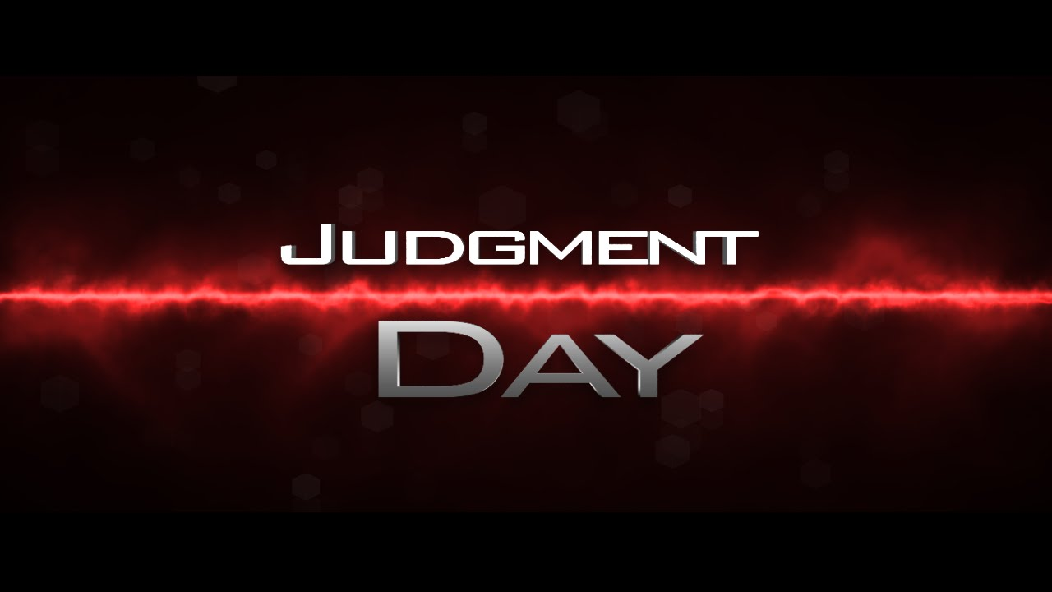
The Bible objectively teaches the reality of future judgement, for God “has appointed a day on which He will judge the world…” (Acts 17:31), and “when the Lord Jesus is revealed from heaven with His mighty angels, in flaming fire taking vengeance on those who do not know God, and on those who do not obey the gospel of our Lord Jesus Christ. These shall be punished with everlasting destruction from the presence of the Lord and from the glory of His power” (2 Thess. 1:7-9). Wishing that no one is going to spend eternity in the lake of fire and all are going to be eventually universally saved does not change anything.

TRANSITIONING – FROM THE OBJECTIVE TO THE SUBJECTIVE
In order to feel closer to God and to obtain a better understanding of the Divine, Emergents must use the intangible senses rather than the tangible objective Word. Though the knowledge of God is found in the Bible, He must be found subjectively. Many Emergents are Neo-Orthodox with regard to the Scriptures—They would deny the truth claimed in Ps 119:160a, “The entirety of your word is truth,” and say the Bible only contains the Word of God. With this in mind, they needed a new method of interpretation—Higher Criticism—that would assist them in determining what parts of the Bible are God’s word and which parts are not.

In the past many Religious Liberals argued that an objective interpretation may have been valid in the past in order to obtain a certain level of God consciousness. However, in order to progress to a higher plane of God consciousness a God conscious individual living in a postmodern world now needs to transition from the objective to the subjective interpretation of not only the Bible, but even other religious writings as well, including ecstatic experiences. As a result of abandoning the objective exegesis of Scripture in its entirety, the content of the Bible becomes less meaningful. Emergents do not concern themselves with the meaning of the Bible—what the original authors intend to communicate, it’s not relevant to them.

STEALTHY - OLD AND NEW SCHOOL LIBERALISM

Old school liberalism attacked the Bible directly by plainly stating that the Bible is full of errors, written solely by mere men who embellished stories they made up in order to control others. They claim the authors of the NT “followed cunningly devised fables”, which Peter denies (2 Pt. 1:16), stating “for prophecy never came by the will of man, but holy men of God spoke as they were moved by the Holy Spirit” (1:21).

New school liberals, Emergents, give the impression that they have a high regard for Scriptures, after all they read and quote the Scriptures often. They give the appearance of elevating the status of the Bible by considering it to be a “living thing”. However, Emergents attack the Bible indirectly by claiming no one can know for certain the meaning of what God said, thereby making the Bible irrelevant, inaccessible, and meaningless. Don’t be fooled!
On the other hand, the Bible itself claims that God has spoken in Scripture using words that He expects people to understand and know, that they will be held accountable for what He has said. “There is no indication that God’s word is vague, unclear, cryptic or subject to multiple meanings” just waiting to be discovered.

The Biblical authors made calculated and careful arguments. They believed the Scriptures could be known, understood, and interpreted objectively. It is true, Peter considered some of Paul’s writings difficult to understand. However, he did not say that his writings were impossible to understand or that we cannot know with certainty what he meant by what he said.

Careful Christian theologians make every effort to define words and explain truths that can be understood and expressed with meaningful words, even by the average person. Christians believe that we can know the words and understand the meaning of what the original Biblical authors penned and intended to say. As a result, we believe that we are accountable to these words as God’s authoritative expression of His will, revelation of Himself. Emergents do not believe people will be accountable to these words since we do not know exactly what they mean.

Since the time of the Reformation most Protestant theologians attempted to objectively determine the meaning of Scripture through Biblical exegesis. Each passage of Scripture was considered to have a single meaning determined by the Spirit inspired author. Plain headed readers or students of the Bible attempt to determine and understand that meaning consistently using the objective historical/grammatical method of interpretation—a completely legitimate and valid method of interpretation still relevant today.

A valid hermeneutic is where the author’s intent determines the meaning and that the use of sound grammatical and historical analysis of the text can reveal the true meaning. There is no legitimate reason to seek another method of interpretation, especially one that leads to a plethora of possible meanings. In fact, “We cannot understand any authors meaning without a consistent hermeneutic that makes knowing such meaning possible.” The means to grow in holiness is first acquired by gaining a better understanding of the Word and His promises, then by living daily based on that understanding.


“UPON THIS SAND…” – FOUNDATIONALISM ABANDONED

Emergents reject the Bible as foundational or authoritative of even basic simple truths concerning God. They reject foundational truths, simply, “givens”, basic truths most people take for granted, “self-evident truths”. They empty the Bible of objective content and replace it with subjectivism. They claim we cannot know anything or very little objectively about God and the world we live in, therefore we must just abandon ourselves to the subjective speculative world.

Emergents refuse to submit their ideas to the authority of the Scriptures and have replaced themselves as the authority. They arrogantly think their idea of the future is better than God’s idea, or the idea an objective interpretation of Scripture portrays. They ignore and ridicule the entire matter of future judgment to their own peril. They mock the "Left Behind” crowd of Jesus coming in fiery judgment, as the “Jihadi Jesus”, coming with guns, tanks, and planes a blazing.

However, there is no doubt that an objective interpretation of the Bible, a literal one, clearly states that a future judgment will occur in time, on the earth and in heaven, and that everyone will be held accountable to God. He has provided ample warning and evidence within the created world that surrounds us, and in His written Word which He has spoken. “Your Word is truth” (Jn. 17:17). Both general and special revelation are the tangible evidence that God has spoken and acted in history, therefore, “ungodly and unrighteous men are without excuse” (Rom. 1:18-20).

How can they “go on to perfection” (Heb. 6:1) and create their better world when they haven’t even learned “the elementary principles of Christ”. Many Emergent theologies claim at least that they were taught to them, and many even believed in them at one time, but now reject them. Now, they completely deny the fundamental principles of the Christian faith—denying Christ’s person, provision and promise. By doing so they categorize themselves as a classic Christian cult—a destructive heresy! They jumped off the solid rock and into the sinking sand.

CONTEMPLATIVE MYSTICISM – “ENTER THE SILENCE”

Having abandoned the objective for the subjective, Emergents fill the void by embracing contemplative mysticism in order to come to God and grow spiritually. Many use the “lectio divina”, “a practice that ignores the meaning of the Biblical authors and instead seeks a personal revelation or spiritual experience from a word that will spring out of the context of the page to the practitioner…” “lectio divina” is supposedly one of the lost secrets, recently rediscovered, from medieval times. The Emergent Dan Kimball would like to reinstitute “vintage Christianity” and laments that the Church “has neglected so many of the disciplines of the historical church, including weekly fasts, practicing silence, and lectio divina.”


“Contemplative Prayer/Spirituality and centering prayer originated from the “lectio divna”, mystical and sometimes occult-based practice of the Roman Catholic Church. Some use the “labyrinth”, usually an intricate maze to meditate in, with a basis in Greek, Egyptian and Cretan Mythology and used in Tantric Buddhism. Mystics contend the utilizing a labyrinth will supposedly bring a relaxed attitude and ends the search for life’s meaning. In reality, this road leads to New Age mysticism and even the occult.”

Contemplate meditation’s aim is to discover God through silence, the area between one’s thoughts, a thoughtless realm. Because God is so great, mere words cannot describe Him. He is so unknowable through words that He must be found through silence. Now that is truly mysterious, or outright strange!

Emergents obtain the meaning of God’s revelation “through spiritual experiences pursued together in community with others… the experience of all individuals in the group determine what a passage means at that particular time”, so then Emergents are “people experiencing meaning together”. The collective experiences of the congregation of Emergents provide meaning, subjectively discovered.


SPIRITUAL FORMATION – THE LOST DISCIPLINES

Others use “Spiritual Formation”, fasting and silence. “Spiritual Formation is the process by which people use various ‘spiritual disciplines’ designed to make people feel closer to God and a greater sense of inner peace.” The spiritual disciplines—fasting, contemplative mediation, centering prayers, solitude, simple living, and submission to a spiritual overseer—are promised to help those who practice them to be more Christ-like.

Christian philosopher Dallas Willard, a leading proponent, claimed that failing to practice the spiritual disciplines deemed necessary for Spiritual Formation is the reason why most Christians are failing to live lives pleasing to God. The ordinary traditional means such as Bible study, prayer, fellowship, and evangelism are inadequate and have failed and have left most Christians as failures. The spiritual disciplines are rigorous activities (hard work), offered as the solution to the problem, to recover practices vital to the Christian life that were lost. These practices are said to be based on Jesus’ lifestyle and supplemented by practices of the Medieval Catholic Church.
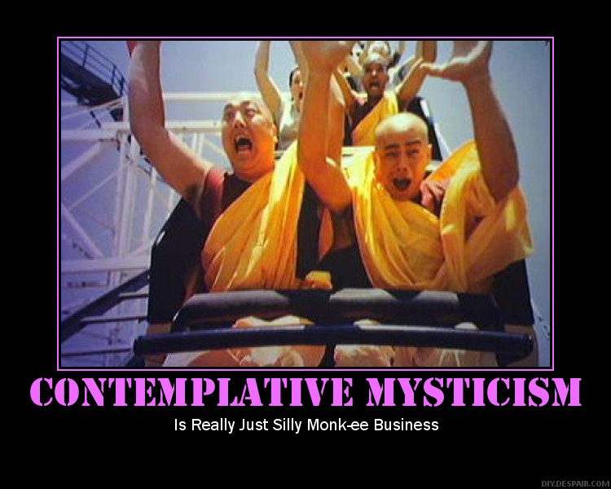
Spiritual disciplines vary, and there are many, they are, “disciplines of abstinence” (solitude, silence, fasting, frugality, chastity, secrecy, sacrifice) and “disciplines of engagement” (study, worship, celebration, service, prayer, fellowship, confession, submission) and other miscellaneous activities (voluntary exile, night vigil of rejecting sleep, journaling, OT Sabbath keeping, and physical labor). If all this activity sounds strangely familiar, that’s because they are all elements of monastic asceticism, which were never really lost. In fact, they are still practiced by many today in both Roman Catholicism and Eastern Orthodox Christian churches. There are little differences between the mystical practices of the Emergent Church—breathing exercises, repetitive mantras and contemplative mystical silence and those practiced today by Hindus, Buddhists, Muslims, and Jews. And thanks to Dallas Willard and through the former leadership of Mystic Richard Foster, he is excited to tell us that these ascetic practices have entered evangelicalism.

While being silent before God is not inherently wrong, contemplative prayer by which one empties the mind of all thought is a practice characterized by false religion rather than Christianity. “Deep prayer requires deep concentration and thought toward God, not the opposite. To ‘stop thinking’ or to ‘move beyond thinking’, the result is subjective and an irrational approach to God.” This “state of silence” can be very dangerous for no one knows who or what is going to fill it. It becomes a channel for the occult and demonic influence. How else do you think that doctrines of demons are introduced?

SPIRITUAL DISICIPLINES FROM THE AGES

A major problem that Willard and other Emergents have is that these Medieval and Monastic practices are not found in the Bible. He does not deny it, but readily admits it. His solution is to argue that Paul did not write about the spiritual disciplines because everyone in the Church was already practicing them. Willard says it was, “utterly unnecessary for Paul to say explicitly, in the world in which he lived, that Christians should fast, be alone, study, give, and so forth as regular disciplines for the spiritual life.”—Here is a classic example of arguing from silence, which is a common practice of false teachers who simply make stuff up.

Again, Willard admits the Bible does not command us to practice the spiritual disciplines he prescribes, rather this great wisdom originates from a collective human experience down through the ages of religious history.

“But thoughtful and religiously devout people of the classical and Hellenistic world, from the Ganges to the Tiber, knew that the mind and body of the human being had to be rigorously disciplined to achieve a decent individual and social existence.”

So, not only is there is not a single author of the NT who wrote about these ascetic practices, in fact, Paul wrote against them,

“Therefore, if you died with Christ from the basic principles of the world, why, as though living in the world, do you subject yourselves to regulations — "Do not touch, do not taste, do not handle," which all concern things which perish with the using — according to the commandments and doctrines of men? These things indeed have an appearance of wisdom in self-imposed religion, false humility, and neglect of the body, but are of no value against the indulgence of the flesh” (Col. 2:20-23).

Paul warned the Colossians not to let anyone rob them of their reward by false humility and subjecting themselves to routine regulations, like spiritual disciplines, for even severe treatment of the body by abstinence or rigorous activities cannot help us find freedom or success from sinful passions of the flesh.

Paul warns Timothy, “that in latter times some will depart from the faith, giving heed to deceiving spirits and doctrines of demons… forbidding to marry, and commanding to abstain from foods which God created to be received with thanksgiving…” (1 Tim 4:1-3a). Though we are not to trust in uncertain riches, we are to trust in the living God, who gives us richly all things to enjoy” (1 Tim. 6:17). Thus, it is erroneous to believe that celibates who abstain from certain foods are holier than thou. Dallas Willard is mistaken to believe that those who fail to practice the spiritual disciplines, Spiritual Formation, are failures.

Monastics, those who practice asceticism alone ignore the responsibility to go into all the world and preach the gospel. Though we are not of the world, we are in the world and the church was never intended to be isolated from the lost world. Followers of Christ are told to deny oneself (Luke 9:23), but following strict rules of abstinence and solitude will neither save, nor sanctify. Christians do not need to follow a set of rules, but follow Christ who has set us free. We are saved by grace and we are to live by God’s grace. “Stand fast therefore in the liberty by which Christ has made us free, and do not be entangled again with a yoke of bondage… you who attempt to be justified by the rule; you have fallen from grace” (Gal 5:1,4b).

The Reformers, who were all former monks, abandoned the ascetic life and eliminated the spiritual disciplines as a rule for Christian living. Now, Christian mystics are attempting to reinstate them. Dewaay is amazed by this current trend in our churches,

“To hear evangelicals like Dallas Willard and Richard Foster tell us that we need practices that were never spelled out in the Bible to become more like Christ or to get closer to God is astonishing. What is more astonishing is that evangelical colleges and seminaries are requiring their students to study practices that are relics of Medieval Rome, not found in the Bible, and closely akin to the practices of many pagan societies.”

Besides, the Church has been there and done that! When these practices ruled the day, it plunged the church and the world into what is known as the Dark Ages. Do we really want to go back there? One of the reasons for the Reformation was to get rid of these abusive and failed practices. Let’s keep them there!

The antiquated Church wants these non-Biblical practices to replace the ordinary means of God’s continued work of grace through the progressive process of sanctification which He began at justification and will not completed until the day of our resurrection unto glory. Let’s not let them! Paul would call them fools for attempting to be perfected by the flesh (Gal. 3:3).

For the Emergent Church the written words of God objectively understood does not, cannot convey any reliable meaning, therefore, spiritual experiences induced by mystical practices become the source of meaning and growth for individuals and congregations. “The more this concept is embraced, the less important the Scriptures become, and the more important the mystical spiritual practices become.” Jeremiah knew them will,

“For My people have committed two evils: They have forsaken Me, the fountain of living waters, and hewn themselves cisterns — broken cisterns that can hold no water” (Jer. 2:13).

Question: If you do not feel close to God, guess who moved? It certainly wasn’t God! The believer gets close to God by continuously looking into the mirror, the Word of God, and beholding the glory of the Lord. Paul gives us the formula for change, “But we all, with unveiled faces, beholding as in a mirror the glory of the Lord, are being transformed into the same image from glory to glory, just as by the Spirit of the Lord” (2 Cor. 3:18).

We are to read, study and understand the Scriptures, to believe and to obey His commands which He has spoken. He holds us accountable to understand the meaning of His words. He has given us the Holy Spirit to help us understand and apply His word to our life. A better understanding of His Word is the means of growth in sanctification and godliness. Let us not replace Biblical practices with works orientated and man centered practices created by spiritual innovators.

It All Boils Down to This: Emergents do not believe the Bible objectively interpreted and applied is sufficient in itself for knowing God, and adequate for life and godliness. What God has plainly stated and prescribed in His Word is not enough for them. They want something more—more knowledge, secret, mystical knowledge, and more power and control over their lives. But, it’s all a lie! In return they actually lose control to supernatural demonic powers, adopting doctrine of demons, and lose their mind to nonsensical, illogical absurdities. “Oh, get behind me Satan.” God has spoken and spoken loudly! How dare you say that subjectivism, mysticism, and silence are more adequate ways of knowing God and theological truth than objective rational words which God has spoken plainly for all to see and understand.
“SILENCE NO MORE” – A PERSONAL STORY

Stephanie Griffin shares her personal experience in a tell all book, “Silence No More, Delivered from the Deception of Spiritual Formation”. After nearly three years of training and enrolling in a Master’s in Spiritual Formation Degree, God intervened in her life! Having been delivered from the depths of this false revival and its mystical practices, Stephanie now reveals her deep understanding of its dangers and false teachings in Silence No More….

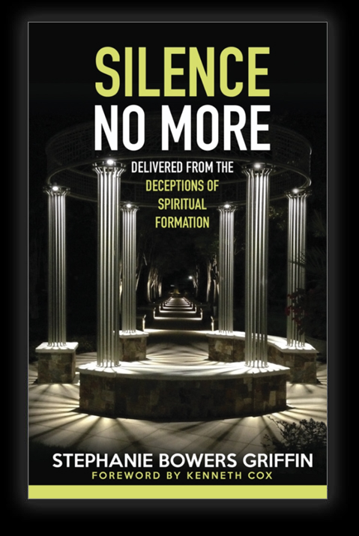
“I had never heard of Spiritual Formation. But for me, it seemed like the life-giving answer to all of the hurts, disappointments, and harshness of life and religion. Reading my Bible, the Spirit of Prophecy, and spending time in prayer were the foundation of my relationship with God, and Spiritual Formation seemed to be built on all that. It seemed rooted in the same values I held, and it also appeared to offer beautiful ways of nurturing and enhancing my prayer life. It was very exciting to have someone come alongside me at a time when I felt so spiritually lonely. It felt beautiful and welcoming to me…

I embraced almost every practice and experience it has. I created my own sacred space in my home, complete with my singing bowl, finger labyrinth, flickering candles, poems, art, and any other object I found meaningful at the time.

I had a Spiritual Director for many years, was myself becoming a Spiritual Director, and had directees whom I was tending. But after completing two-and-a-half years of a three-year program, something just did not feel right…

“I remember feeling lost, scared, and even empty. I wondered what was to take the place of Spiritual Formation in my life. Would I be giving up a closeness with God I felt I had? It was like a drug to me, and now there was nowhere to go for a fix, nothing to replicate what I felt during my Contemplative Prayer time. I remember the doubt that crept in, and how each time I decided to go with the facts, rather than my feelings.

In time, that void was filled with something far greater; something very different, but much greater and tremendously more powerful and effective. That’s what happens when the Holy Spirit is allowed into our lives. We receive power from on high—a Power that produces results, instead of working so hard and gaining nothing in return, as was my situation for far too long.”

MY EMERGING STORY

One inconspicuous Sunday a member of the church committee insisted that the leadership team needed to get together more often and “dialogue” regularly. We were a very small church and met when needed, and that seemed to suffice. Ok, we agreed to start meeting once a month to “dialogue”, you know, the usual church business. What I and the others didn’t know is that he had something much more in mind in using that precise term.

Sometime earlier he had introduced us to “Spiritual Formation”, giving us a CD and a booklet describing what first appeared to be a plan for personal spiritual development. I listened and looked over the material. It seemed to be vague and very subjective. He also wanted us to meet regularly to exercise “Spiritual Formation”. We basically told him, “We’re not interested”. You could tell, he wasn’t happy.

At that time, I began to do some research to discover for myself what “Spiritual Formation” was all about. It sounds like, “Spiritual Transformation”, right? That’s good! What I found was not good. It turns out to be nothing more than Christian mysticism disguised as leadership training. Now, why is a graduate of a conservation Theological Seminary attempting to involve us in Christian mysticism? I found it amazing that many Christian Seminaries, even conservative ones, have a program in “Spiritual Formation.”

Sometime later, our senior pastor was no longer able to preach, having been in a serious car accident. In the interim, I was supplying the pulpit every Sunday on top of a full-time job. After a while, others wanted this other member also to preach. I told the pastor, “I don’t think that’s a good idea.” I was already suspicious of his theology. But at least I’ll get a break. After all he is a graduate of Dallas Theological Seminary and we had nobody else trained in Biblical studies, and he knew Greek.

When he preached, he had no outline, no structure, and would jump from one passage of Scripture to another and then back again. It was almost the same message every week, over and over again. He would say strange things and emphasize how we needed to transition from the “tangible” to the “intangible”. He Referred to the Jews who needed to let go of the physical temple and grab hold of the temple made without stones, that is, the church. In other words, we need to transition from the “objective” to the “subjective” if we expect to grow in the Lord Jesus Christ. It all seemed very strange talk, “dialogue”, that is.

I asked people in the congregation, “Do you know what he is talking about?” They would say, “Not a clue” or “Not sure”. I thought I had an idea about what he was dialoging about, but I could not pin it down exactly. What was the source? I didn’t think he was making it up on his own. And I was right.

Now, I know that the “dialogue” had something to do with postmodern thought. As I was searching the web, I came across the “Emergent Church”. And it hit me, there it was, as plain as day. I had the source and connection to the “dialogue”. I had heard about the Emergent Church but did not know the extent of the “conversation” within evangelicalism. Only a very few were tossing up the red flag. However, we should not be surprised, for Peter predicted, “…that false teachers will secretly bring in destructive heresies” (2 Pt. 2:1). Jude later described that, “certain ungodly men had already crept in unnoticed” (Jude 4), they had infiltrated the Church. Paul warned us that many would depart from “the objective faith” in the latter days.
“Watch, stand fast in the faith, be brave, be strong. Let all that you do be done with love”
(1 Cor. 16:13-14).

“Stand therefore, having girded your waist with truth”
(Eph. 6:14).

ADDENDUM

LEADERSHIP: Doug Pagitt, Brian McLaren, Rob Bell, Tony Jones, Barry Taylor, Dwight J Friesen, Miraslov. Contemplative adherents are Henri Nouwen, Thomas Merton, Leonard Sweet, Thomas Keating, Richard Foster, Dallas Willard, Tony Campolo, and Frank Viola.

ORIGINS: Georg Hegel (German Idealist), Jurgen Moltman LeRon Shultz, Wolfhart Panenberg, Stanley Grenz, (German Theologians), Dallas Willard, and Rick Foster (Spiritual Formation).

SOURCES: Hegel and his German philosophical followers are the founders of the Emergent Church. They developed romanticism and idealism which have deceived many. “The worldview presented by the theology of Grenz, Pannenberg, Moltmann, and Shults is the bedrock foundation of the Emergent Church movement.”

Georg Hegel – developed the idea that contradictions through the process of history could synthesize into a better future. The cross and the resurrection are dialectic, “opposites” that can be synthesized into an emerging new reality in which we can participate. Christians and atheists (opposites) can work together for a better future. Everything is to be interpreted through a dialectic process.
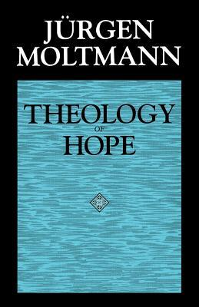
Jurgen Moltmann – developed a Christian version of Ernst Bloch (atheist) principles of hope to a Christian theology of hope. Moltmann embraced Hegelian dialectic philosophy. He is the source of Emergent eschatology. Moltmann fought for Nazi Germany, but later became a theist and created his “Theology of Hope”, a hope of a future paradise without judgement through social and spiritual evolution.

Ken Wilber – is the source of emergent philosophy. “Wilber is a mystical Darwin, promoting a “holistic” concept of evolution in which things are not only evolving physically but also spiritually. This spiritual evolution is the basis of “spiral dynamics” where the world evolves into the physical/spiritual paradise over time.”

Moltmann Theology + Wilber’s Philosophy = Emergent

The bottom line is that Emergent Theology comes from philosophy, not from careful Biblical interpretation. The ultimate source comes from the pit of Hell.

Fredrich Schleiermacher – called the “Father of Modern Liberal Theology.” As a philosopher he was a leader in German Romanticism. He accepted Kant’s fundamental principle that knowledge is bounded to experience. In His chief theological work, The Christian faith according to the principles of the Evangelical Church, “the source of the basis of dogmatic theology are religious feelings… not the creeds or the letter of Scripture or rationalistic understanding.” The aim of the work was to reform Protestant theology, to put an end to supernaturalism and rationalism, and to save religion and theology from ever changing systems of philosophy.

He was instrumental in the modern field of hermeneutics, so much so that he is also considered “the father of modern hermeneutics”. His method of interpretation was to not only consider the “outer expression” in language (the natural or normal sense), but to also consider the “inner thoughts” of the author in order to acquire the “understanding in the highest sense”. He added a psychological process in the interpretation of the text, so the reader can understand the nuance of the author—a kind of psychosocial analysis of the author’s inner thoughts. However, any certainty of actually knowing what the text means “is limited by the possibility of misunderstanding the text”—hopeless uncertainty. His process of interpretation turned theology into psychology—more subjectivity.

BIBLIOGRAPHY

Books:

Bob Dewaay, The Emergent Church, Undefining Christianity, 2009

Bob Dewaay, Redefining Christianity, Understanding the Purpose Driven Church, 21st Century Press, 2008.

Elliott Nesch, Hath God Said? Emerging Church Theology, Holy Bible Prophecy, 2014.

Stephanie Griffin, “Silence No More, Delivered from the Deception of Spiritual Formation”.

D.A. Carson, Becoming Conversant with the Emerging Church, Understanding a Movement and Its Implications, Zondervan, Grand Rapids, 2005.

William D. Henard and Adam W. Greenway, Evangelicals Engaging Emergent, A Discussion of the Emergent Movement, P & H Publishing Group, Nashville, 2009.

Articles:

The Dangers of Spiritual Formation and Spiritual Disciplines, A Critique of Dallas Willard and the Spirit of the Disciplines by Bob DeWaay.

How Spiritual Formation Almost Destroyed My Life –
www.fulcrum7.com/blog/2018/4/11/how-spiritual-formation-almost-destroyed-my-life

Videos:

“Emergent / Emerging Church Documentary”, youtu.be/OF-CHA4Z2FQ

“Emerging Church Spiritualism”, youto.be/ww8GdveNlcM

“Emergent Church Exposed and Defined – SO4J-TV”, youtu.be/YxfobXmmRx8

“What is the Emergent Church Movement?” youtu.be/HoVj5UFlzOw

“John MacArthur on the Emergent Church, pt1”, youtu.be/OH1yOmij704;
pt2, youtu.be/vG3VNrfJsLl

“How to Spot the Emergent Church Entering Yours – Jan Markell / Eric Barger”, youtu.be/opy0lEo Yll

More Information on the American Cults: www.freegracegospel.info/Cults.html

THE ESTABLISHED FAITH
THE EMERGENT CHURCH
God is Creator

God is Immutable – “Never Changes”
Omniscient – “All Knowing”

Trinitarian
God in Three Persons

Jesus was and is the God/Man

The Only One Way to God
is through Jesus

Eternal Salvation/Eternal Life is received by “Faith Alone in Christ Alone”,
Apart from any Good Work.
Eternal Life becomes a Present Possession.

Jesus’ Substitutionary Death and Resurrection is the Basis of Salvation

Salvation is by Faith/Universally Available
But Few are Willing
Narrow Road / Exclusive

Sin is Serious and Grievous;
Is Subject to Eternal Punishment
Required the Death of God’s Son

The Cross is a Demonstration of God’s Love
for Mankind and a Payment for Sin

Salvation is from Hell, a Literal Place,
Eternal Destruction/Condemnation

God Judges and Punishes Wickedness
There is a Coming Day of Wrath on Earth

History is Linear
History has a Beginning and an End
Looking for a New Heaven and Earth

A Premillennial Earthly Kingdom
God is Creativity/Evolver

God is Evolving – Process Theology
God is Learning / Growing in Knowledge

Non-Trinitarian/Panentheistic
God is in All – Paneverythingism

Jesus had a Divine Consciousness

There are Many Paths to God
Jesus is One of the Ways to God

Salvation is a Process of Growing in the Knowledge of God, through Meditation and Missional Service
Salvation is Only Realized in the Future

Jesus’ Death and Resurrection are Contradictions, and Not Understood

Salvation by Anythingism/Universalism
Everyone Eventually Comes Around
Broad Road / Inclusive

Sin is Refusal to Become; Resistance to the Process of Evolution; Whatever Causes a Spiritual Setback or Slows Down the Process

The Cross is a Great Injustice
“Cosmic Child Abuse”

Hell Exists only in the Here and Now
Hell is Not a Place but a State of Mind

Their Dream is a World without Judgement,
A Theology of Hope

History is a Spiral
The World Evolves into a Physical/Spiritual Paradise over Time

A Postmillennial Spiritual Kingdom
THE ESTABLISHED FAITH
THE EMERGENT CHURCH

What God has Spoken through Human Language cannot be Understood; therefore, Mankind cannot be Held Accountable to what God has Said

The Bible is Complicated and Difficult to Understand; Contains Secret Messages

Many Theological Truths are Mystical and are Discovered by Various Mystical or Contemplative Means

All Truths are Relative
The Bible Contains Truth
Yet to be Determined

Neo-Orthodox
The Bible Contains the Word of God
Untrustworthy and Non-Binding
No Boundaries

Truth is Subjective - Uses the Allegorical or Spiritual Method of Interpretation in order to Discover what the Word Means
to the Reader

The Reader Determines the Meaning
of the Text

The Bible is fallible and Contains Error

The Means of Grow in Sanctification is Gained through Group Conversation, Centering Prayer and Mystical Experiences

Post-Modern/Combo Culture

God has Spoken through Human Language and can be Understood, therefore Mankind is Accountable to what God has Said

The Bible is Plain and Simple to Understand; No Hidden Meanings

Theological Truths can be Understood using the Human Mind Alone
No Mystical Experience Needed

Some Truths are Absolute
The Bible Contains
Once-for-all Revealed Truth

Orthodox
The Bible is the Word of God
Authoritative and Binding
Sets Boundaries

Truth is Objective - Uses the Historical/Grammatical Method of Interpretation in order to Discover the Intent of the Word of the Original Author

The Author Determines the Meaning
of the Text

The Bible is Infallible in All its Parts

The Means to Grow in Sanctification is Gained by a Better Understanding and of God’s Word and Promises

Ultra-Modern/Counter Culture

The Emergent Church, Wikipedia
The Emergent Church Explained, www1.cbn.com
www.raptureready.com/2016/08/09/emerging-church
Bob Dewaay, The Emergent Church, Undefining Christianity, Printed in the USA. 2009, p. 51.
John Taylor, “An Emerging Church Primer”, 9marks.org.
Elliott Nesch, Hath God Said? Emergent Church Theology; Holy Bible Prophecy, Monee, IL. p. 3-11.
pubtheologians.com/cana
Nesch, p. 14.
Ibid., p. 15.
Dewaay, p. 239.
John Taylor, “An Emerging Church Primer”, 9marks.org.
Jurgen Moltmann created a Christian theology of hope.
Dewaay, p. 238.
Ibid., p. 14.
Ibid., p. 242-243.
Dwight J. Friesen, “Orthparadoxy: Emergent Hope for Embracing Difference” In An Emergent Manifesto of Hope, Doug Pagitt and Tony Jones (Eds.) 208. Contradictions are seen as good and to be embraced.
Dewaay, p. 241.
Zane Hodges, “Power to Stand, An Exposition of Jude”, GES, Denton, TX. 2016. p. 59-60.
Nesch, p. 65; Judy Harrison, “Worshipper’s dance in the aisles as spirit fills Bangor seminary’s Convocation.” Bangor Daily News, Jan. 12, 2012.
Dewaay, p. 34.
Ibid., p. 13.
Ibid., p. 84.
Ibid., p. 219.
Michael Reeves, Understanding the Roots of Theological Liberalism, Friedrich Schleiermacher, Forum of Christian Leaders FOCLonline.org
Dewaay, p. 146.
Zane Hodges, The Epistles of John, Walking in the Light of God’s Love, 1999 Grace Evangelical Society; 37.
Ibid., p. 38.
Dispensationalism is their greatest threat since it is the only system of interpretation that uses a consistent and objection interpretation throughout Scripture. Dispensationalism does not switch off the historical and grammatical interpretation for all unfulfilled prophecy, but uses it consistently from Genesis to Revelation. Unlike Covenant Theology which changes their hermeneutic to the allergically or subjective interpretation for all unfulfilled prophecy.
Emergent Church, Wikipedia
Nesch, p. 46.
Ibid., p. 88.
Ibid., p. 90.
www.raptureready.com/2016/08/09/emerging-church/
“Revive Us Again”, fourth stanza, John Jenkins Husband | William Paton MacKay.
Nesch, p. 17.
Irenaeus, Ante-Nicene Fathers, volume I 330.331.
Biblical “exegesis” is the critical explanation or interpretation of a text of Scripture in order to determine the original author’s intended meaning.
Even though Emergents claim to reject propositional truth claims, this is one of their own, on the top of their list.
Dewaay, p. 120.
Ibid., p. 102.
Nesch, p. 50.
Ibid., p. 85.
Ibid., p. 194.
They denied the doctrine of inerrancy and infallibility.
Dewaay, p. 126.
“Exegesis” is the method of explaining the meaning of Scripture out of the text of itself, as opposed to “eisegesis” which is importing a meaning into the text. Ideally, exegesis should involve the analysis of the biblical text in its original language—Hebrew or Greek. This requires a lot of skill and hard work. Emergents would rather take the easy road and just make up something.
Ibid., p. 79 – “Hermeneutics” is the interpretive principles or methods by which someone comprehends a Biblical text.
Ibid., p. 180.
There is only one true meaning of any given text, but many applications of that meaning. This ought to be one of the first propositional truths any Bible study should know and apply.
Ibid. p. 143.
Dan Kimball, The Emergent Church: Vintage Christianity for New Generations (Zondervan, Grand Rapids, MI. 2003), p. 257,258.
Eric Barger, youtu.be/opy0lEo Yll.
Dewaay, p. 113-114.
Ibid., p. 142.
Bob Dewaay, Critical Issues Commentary, Nov./Dec. 2003, Issue Number 91, p. 3.
Nesch, p. 191.
Dewaay, 3. cicministry.org/commentary/issue91.htm
Ibid., p. 4.
Ibid., p. 4.
Dewaay, The Emergent Church, p. 114.
www.fulcrum7.com/blog/2018/4/11/how-spiritual-formation-almost-destroyed-my-life
Dewaay, The Emergent Church, p. 211.
Ibid., p. 211-237.
Kant asserted that, because of the limitations of argumentation in the absence of irrefutable evidence, no one could really know whether there is a God and an afterlife or not. (https://en.m.wikipedia.org/wiki/Western _philosophy)
Friedrich Schleiermacher, Wikipedia.

